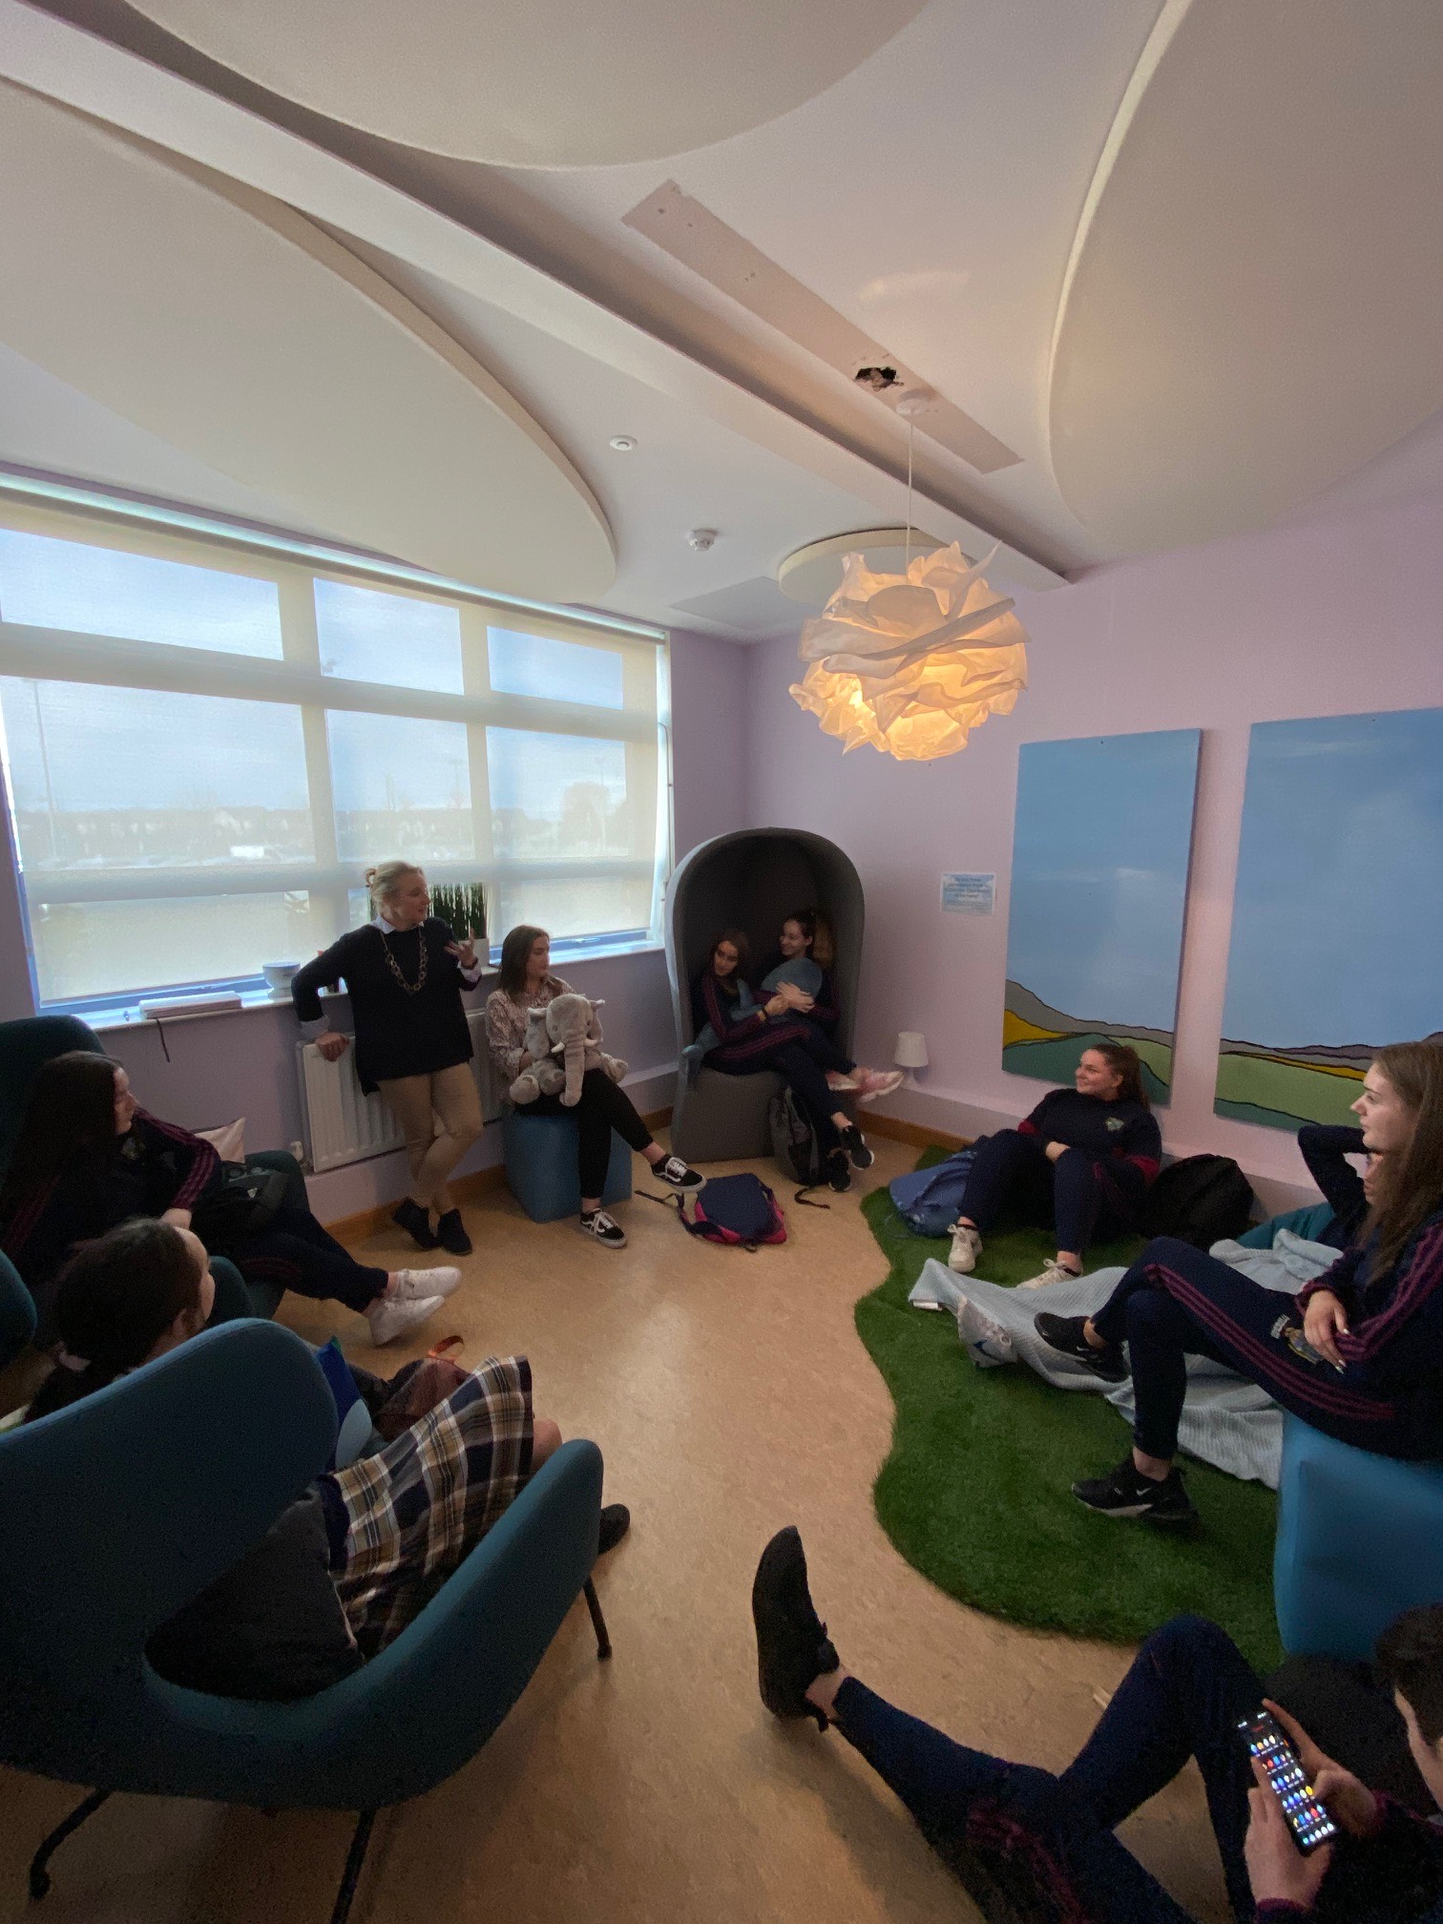

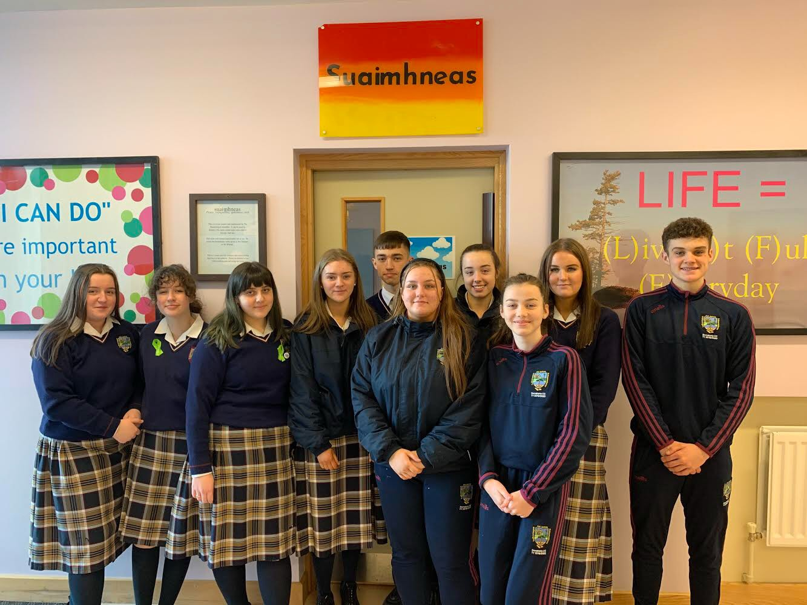

**HOW WE DID IT:**

We raised funds, designed the room and then decorated the space ourselves. We also formed a relationship with a large business who offered funding and also donated furniture to be used. The name 'Suaimhneas' was decided on as the name for the room.

**ADDITIONAL COMMENTS:**

The room is now used as a meeting space for the committee, as a shelter for overwhelmed students during the school day and as a space for the guidance counsellors to use for counselling sessions. It has been a huge success.

**WHAT WE DID:**

The idea we had was for a safe space students could go to when feeling overwhelmed. We felt this was missing from our school. We floated the idea to our link teacher and the other teachers involved in the Headstrong committee and they loved it. We consulted the guidance department who asked to be involved and offered a room fit for purpose.

**COMPLUSORY THEME / OPTIONAL THEME**

**TITLE OF THEME:** Look out… how to talk about it

**SCHOOL NAME:** Donate Community College