**HOW WE DID IT:**

The Headstrong Team compiled a list of tips for dealing with stress in the lead up to the house exams and the mocks. They made a visual display at the main entrance of the school for all students to see and take note of. The team also organised a wellbeing class for sixth years to help them deal with stress. They had a relaxing time coming up with a funny and unusual ‘life hack’ and adding them to the wall.

**WHAT WE DID**

Stress Awareness Wall

Life Hacks Wall

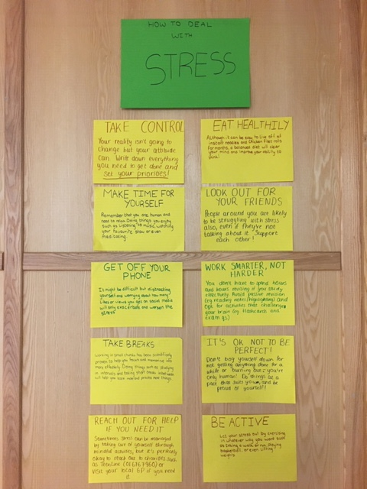

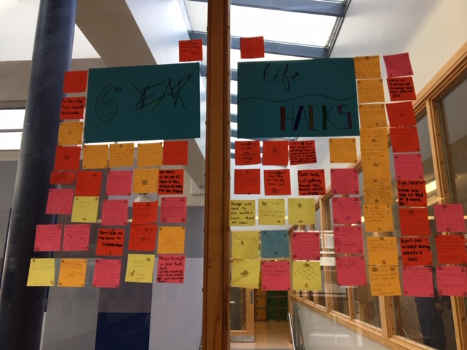

**COMPLUSORY THEME / OPTIONAL THEME**

**TITLE OF THEME:** Coping With Stress

**SCHOOL NAME:** Adamstown Community College

**ADDITIONAL COMMENTS:**

The stress awareness wall was a great activity for helping the whole school community to learn about different ways to combat stress.

The life hacks activity was a great way for students to take a break from the stress of exams and be creative in their hacks.