**HOW WE DID IT:**

We had a tree of hope which tied in with the theme of bullying. Students learned about bullying in class. Then they had to write a positive message on their ornament and hang it on the tree. We also had a door contest and my door was a ‘’Positive-i-tree Door.’ Students learned about the importance of being kind to one another and this was a nice activity to finish the term and recap what they learned. The students wrote a positive affirmation on the decorations on the door. There was also key word vocabulary that linked in with what they learned in class that pertained to wellbeing

**WHAT WE DID:**

Tree of Hope

Positive-i-tree Door Decoration

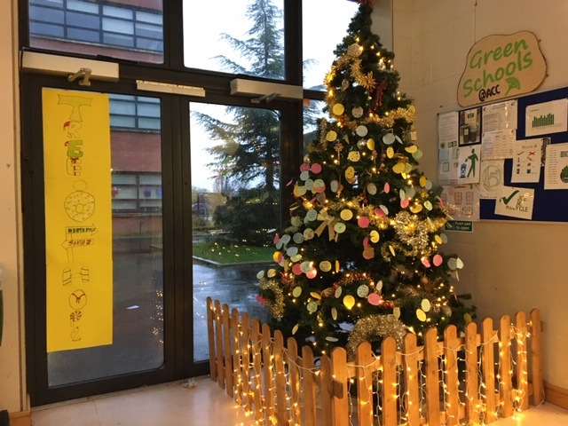

I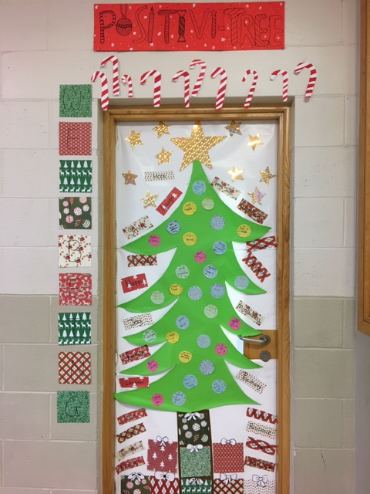

**COMPLUSORY THEME / OPTIONAL THEME**

**TITLE OF THEME:** Bullying

**SCHOOL NAME:** Adamstown Community College

**ADDITIONAL COMMENTS:**

Both of these activities were great visual reminders of how important it is to create a kind atmosphere in the school community. The Headstrong Team organised the supplies and it was a student lead initiative where they helped younger students to participate in both activities.